C# Basics



INSTRUCTOR: ADEEN BIN WAHEED LECTURE 2

C# Program Structure

A C# program consists of the following parts: ⮚Namespace declaration

⮚A Class

⮚Class methods

⮚Class attributes

⮚A Main method

⮚Statements and Expressions

⮚Comments

Some Important Basic Elements

**The using Keyword:** (using System)

The using keyword is used for including the namespaces in the program. A program can include multiple using statements.

**Class:**

The class keyword is used for declaring a class.

**Comments in C#:**

//This is a comment

Or

/*This is a comment*/

Variables

A variable is a location in memory that can hold values of a certain data types. Each variable must be declared before it is used.

The declaration allocates a location in memory to hold values of this type.

Variables Example

using System;

class Program

{

public static void Main()

{

int x;

x = 3;

Console.WriteLine(x);

x = 4;

Console.WriteLine (x);

}

}

Data Types

The variables in C#, are categorized into the following types: ⮚Value types

That stores values directly in the storage memory.

⮚Reference types

Reference type variables store the address of the object containing the data. For example:

A a=new A();

⮚Pointer types

Value Types

Value type variables can be assigned a value directly. They are derived from the class **System.ValueType**.

The value types directly contain data. Some examples are **int, char, and float**, which stores numbers, alphabets, and floating point numbers, respectively. When you declare an **int** type, the system allocates memory to store the value.

There are following Value Types in C#:

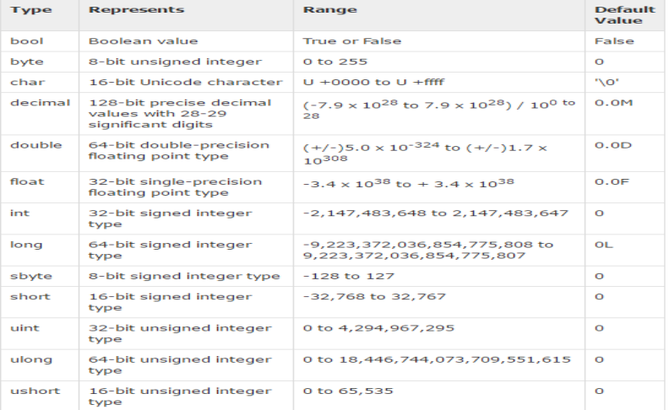Value Types

Global Variables and Constants

There are no such global variables in C# as we were having in C++.

But there is a way, that you can use static keyword for using a variable as a global variable. **For Example:**

static int var=2;

We can also make constants in C# using const keyword.

**For Example:**

const int VAR=5;

Input / Output (I/O)

To output in C# we will use following syntax: Console.WriteLine(“Hello”);

To input a value in C# we will use following syntax: String s;

s=Console.ReadLine();

C# Code Example

**Running Demo**